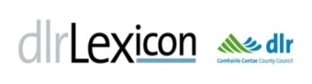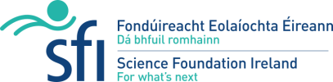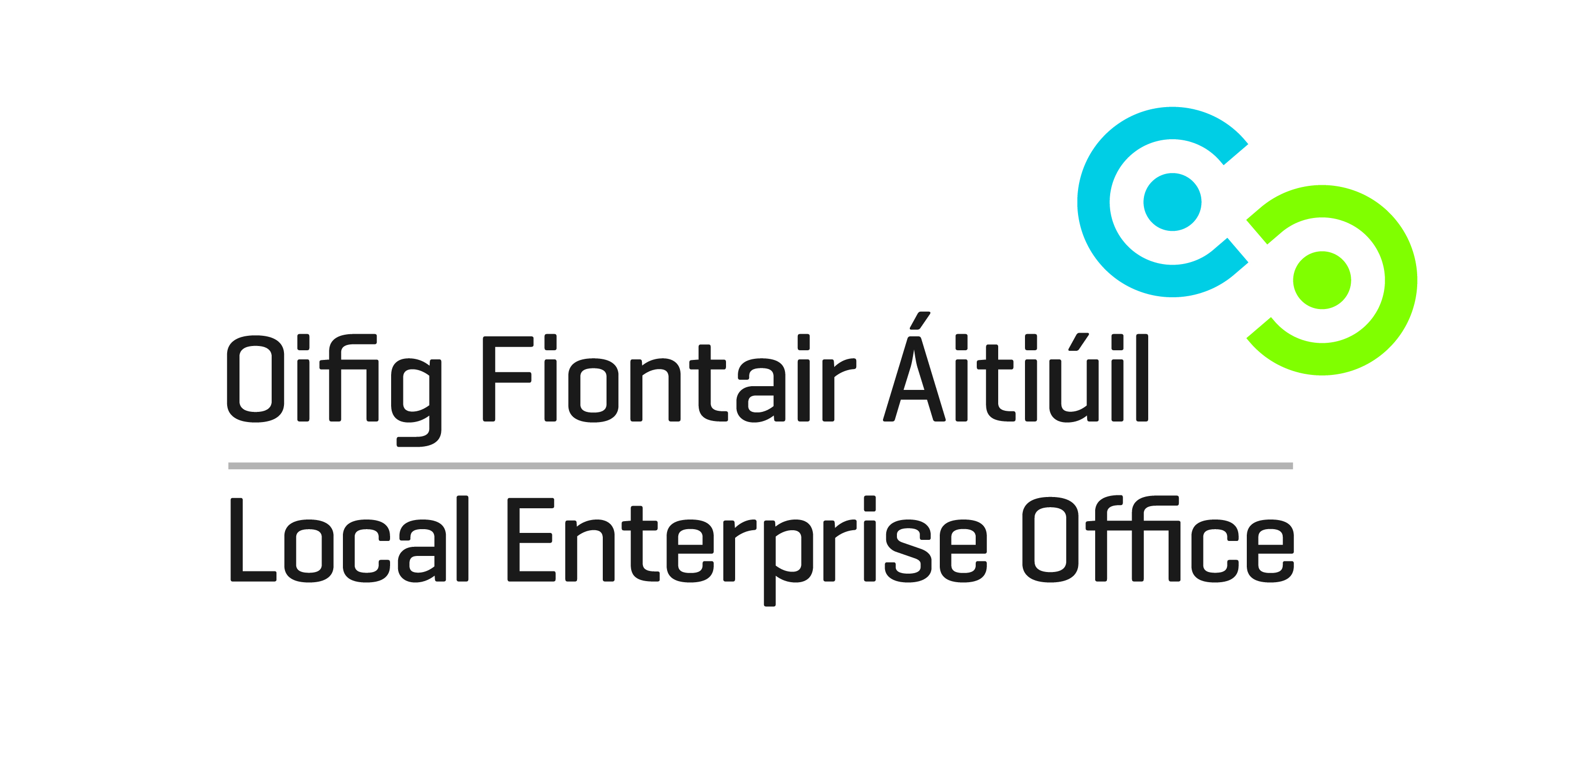
dlr Teen Entrepreneur STEM Camp & Hackathon 2018
OPEN TO TY STUDENTS IN DLR SECONDARY SCHOOLS ONLY FREE
Certification and Presentation 2017

At STEM SHOWCASE;
November 30th 2017.

Students reported that the Camp encouraged and developed their STEM and entrepreneurial skills.

More information:
http://libraries.dlrcoco.ie/library-services/dlr-lexicon-lab

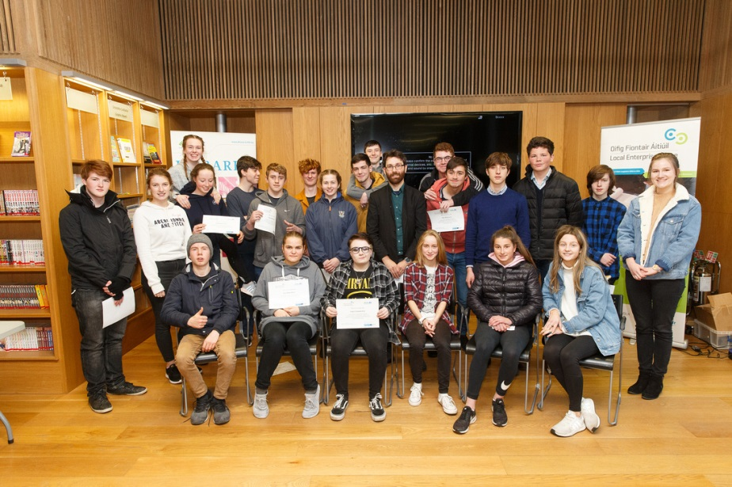

Our Third STEM initiative for Transition Year students will be held
October to December 2018

Teachers should APPLY BY WEDNESDAY, MAY 9TH (Limited to 15 schools, 4 students per school)

Dún Laoghaire-Rathdown, Libraries and Local Enterprise Office, are delighted to host our third Entrepreneur Learning Camp in STEM (Science, Techology, Engineering and Maths) for Transition Year students this Autumn (with the addition of a STEM Hackathon). There is no charge. The programme will once again be planned and facilitated by Dr. Jake Rowan Byrne.
New Photo – date etc??
Place link in document to web site
Blue highlight – check content for accuracy
Will Public session for Hacketon allow access by parents?? Suggest Stem camp should consider same??

The venue, dlr LexIcon LAB, offers programmes on coding, computer programming, 3D printing, robotics and other creative technologies. The camp’s weekly sessions from October to November 2018 will include; Workshops, Guest Entrepreneurs and Project Maker Days; culminating in a Show and Share Event. The programme is cross curricular and relevant to: Applied Maths Curriculum; Business/Enterprise, Science Subjects, Art and Design; Mechanical Drawing; Technology and Engineering; Career Guidance.
Our first dlr TY STEM Hackathon follows in early December.
Camp Objectives
- To familiarise participants with STEM using coding, basic electronics, robotics and design software
- Develop STEM skills using new creative technology
- Promote problem-solving skills
- Encourage entrepreneurial skills
- Foster teamwork, collaboration and learning from work

Workshop Topics
- Coding; Scratch, Python and Ardunio
- Electronics and programming; Raspberry Pi and Arduino
- 3D Design and Printing; CAD
- Prototyping; Design thinking and paper prototyping

Learning Outcomes
- Acquire basic coding skills for developing apps and controlling computer systems
- Learn how to design and print simple 3D objects using CAD
- Develop understanding of how new technologies provide solutions to everyday problems
- Apply problem-solving skills using coding and electronics
- Appreciate the relevance of STEM to career options including enterprise creation
- Develop communication, collaboration and presentation skills
Pedagogy
The four workshops are student-centred with an active learning pedagogy marrying theory and practice. To complete the learning cycle student teams will be challenged to develop a project to integrate and apply their learning for sharing at a final presentation event with their peers.

CAMP PROGRAMME 2018 (Schools divided into 2 Groups to faciliate numbers)
(Times: Group 1: 10.00 am to 12.30 pm & Group 2: 1.00 pm to 3.30 pm Except: Week 6, 7, 8)
4th October | Week 1 | Workshop 1: Coding, Scratch & Java
11th October | Week 2 | Workshop 2: Electronics & programming; Raspberry Pi & Arduino
18th October | Week 3 | Workshop 3: 3D Design and Printing; CAD
25th October | Week 4 | Workshop 4: Prototyping; Design thinking and paper prototyping
Mid Term: 28th October to 3rd November 2017
8th November | Week 5 | Guest Entrepreneur: The Business Plan
14th & 15th November | Week 6 | Maker Days: Group 1 (10.00am to 3.30pm)
21st & 22nd November | Week 7 | Maker Days: Group 2 (10.00am to 3.30pm)
29th November | Week 8 | Showcase of Projects and Camp event (10:00 am to 3:00 pm)

dlr TY STEM Hackathon -THEME: ASSISTED LIVING
Participants from STEM Camp 2018 will also attend a weekend STEM Hackathon on December 7th and 8th. in dlr LexIcon on the theme of ‘Assisted Living’. Students will be challenged by Advocates for assisted living to develop and design proposals for support using STEM skills. The camp will emphasise creative thinking and collaborative work in finding workable STEM solutions culminating with an informal ‘show and share event’ of projects.
7th December 6.00 pm – 8.00 pm | Advocate Presentations and student explorations
8th December 9.00 am – 8.00 pm | Teams work on their projects using the new technologies facilitated by Dr. Jake Rowan Byrne, with technical support and business plan advice. Lunch and refreshments will be available. A winning team will be determined by a hybrid combining Judge and Peer review. The Prize will be a 1 x mentoring session (courtesy of LEO DLR) and Arduino Kits for each team member.
HOW TO REGISTER (DEADLINE WEDNESDAY, MAY 9th 2018)
Please email Maeve McElligott, dlr Libraries: Your Name, School and Contact Details (Email & Mobile)
To: librarybookings@dlrcoco.ie AND cc. joseph.keating@gmail.com
Using Subject line: ‘Teen Entrepreneur STEM Camp / Autumn 2018’
Queries to: Maeve McElligott, dlr Libraries librarybookings@dlrcoco.ie or Joseph Keating, Enterprise Education Co-ordinator, LEO DLR joseph.keating@gmail.com / 087 9956150

Supported and Funded by Science Foundation Ireland Discover Programme (2017)

